Herpes (cold sore) prophylaxis:

* Prevent plant based decongestants:

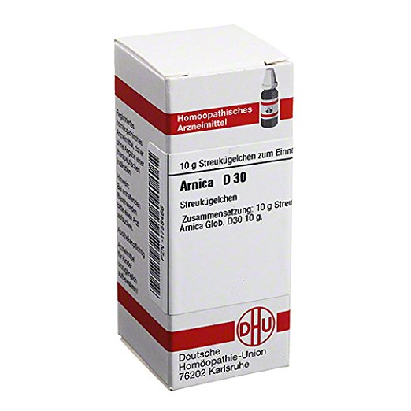 Arnica D30 Globuli ;

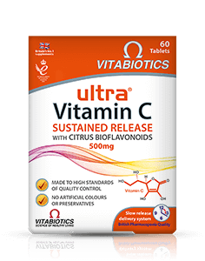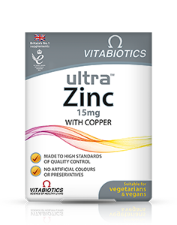 Vitamin C + Zinc

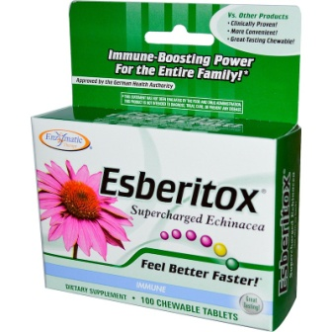 Esberitox

* Aciclovir **tablets** (need to be prescribed from doctor!)

